**Experiment 7 : Develop a program to simulate interfacing with the keypad module to record the keystrokes.**

**Circuit Diagram:**

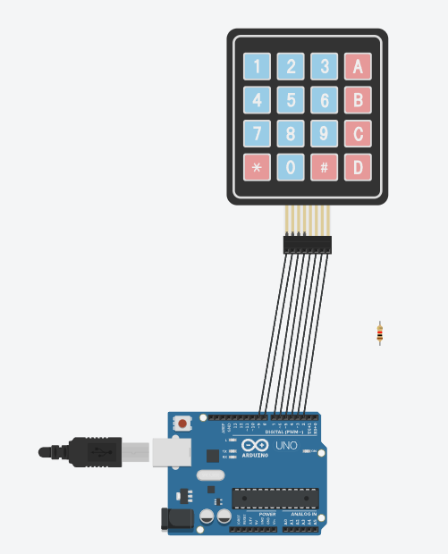

**Code**

**#include <Keypad.h>**

**const byte ROWS = 4;**

**const byte COLS = 4;**

**char keys[ROWS][COLS] = {**

**{'1', '2', '3', 'A'},**

**{'4', '5', '6', 'B'},**

**{'7', '8', '9', 'C'},**

**{'*', '0', '#', 'D'}**

**};**

**byte rowPins[ROWS] = {9, 8, 7, 6};**

**byte colPins[COLS] = {5, 4, 3, 2};**

**Keypad keypad = Keypad(makeKeymap(keys), rowPins, colPins, ROWS, COLS);**

**void setup() {**

**Serial.begin(9600);**

**}**

**void loop() {**

**char key = keypad.getKey();**

**if (key) {**

**Serial.println(key);**

**}**

**}**